# Illustration And Icon requirement

1. All icons and images are required “PNG” format unless further notice.
2. All icons and images are required two sizes and the following naming pattern:

|  |  |  |
| --- | --- | --- |
|  | size | name |
| 1 | normal size (eg.: 2*2 or 10*10) | double size (eg.: 4*4;20*20) |
| 2 | name.png | name@2x.png |

Notice: all the sizes motioned in this document are normal size.

1. All icons and images should have clear color as background unless further notice.

# Image list

1. Aircraft (145 * 116, Opacity 90%). Design and implement **four** aircraft images, each one of them should has a basic shape like “士”, they should full fill into a 145 * 116 rectangle.   
   Please think the rectangle as a box that has 5 * 4 equal size cells and fill it like this (please make them have better looking than this):

|  |  |  |  |  |
| --- | --- | --- | --- | --- |
|  |  | O |  |  |
| O | O | O | O | O |
|  |  | O |  |  |
|  | O | O | O |  |

1. Battlefield grid (290 * 290, Opacity 100%).  
   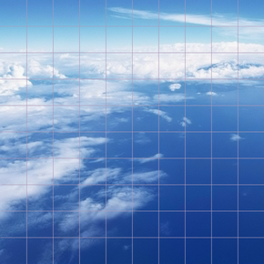
2. Battlefield bar (60 * 580, Opacity 100%).  
   